**CHAPTER THREE**

**The healing of the epileptic**

Aunt Rosaria, the last of numerous offspring, was born on April 4, 1898. My grandmother claimed that she was the only "unlucky" member of the family in that she was subject to epileptic attacks. In addition, of the middle, fourth and little fingers of her right hand had been amputated at the joints because of a minor accident.

My grandmother, in the hope of a cure, took her to Luisa; a group of girls to whom she taught lace-making were on their way to her house. She asked Luisa to let her join them, so that she could learn this craft. Aunt Rosaria was barely nine years old at the time, although she looked older. It was a cold, rainy day in January 1907. Luisa was already famous throughout Corato and everyone called her Luisa the Saint. She was not only a woman who lived a holy life, respected by all, but was also a social worker. Indeed, at home she had set up a lace-making school which in those times was a significant social advancement for many girls, who left their homes and the farming environment.1

This is how the meeting occurred….

It was about 10.00 in the morning when my grandmother went with my aunt to Luisa’s house in Via Nazario Sauro, known as Via dell’Ospedale. Luisa’s mother, an elderly woman, came to open the door and stayed chatting to my grandmother, asking her for news of some relatives.2

At the end of the discussion, Luisa’s mother took them both into her daughter’s room where Luisa was giving the girls embroidery lessons from her bed.

Angelina, Luisa’s sister, had the girls who were making lace leave the room and brought in a chair for my grandmother. My grandmother sat down and the two began to talk.

This is my aunt’s testimony: "*They both talked about different matters that I don’t remember clearly, like two old friends who had not seen one another for some time. Finally, my mother kissed Luisa and left. I had the impression that they had also been talking about me and that Luisa had consented to my mother’s request. When I was left alone with Luisa, she looked at me with a profoundly benevolent expression, as though she wished to encourage me. I had no suspicion of what was to happen to me later, that I would remain beside her without interruption for forty years*"*.*

Several days later, my aunt was stricken with a sudden epileptic fit, just as she was being taught the basic elements of lace-making. My aunt never related this episode, because she was rather shy and reserved about all that concerned Luisa and rarely mentioned her at home. My mother told me of the event; she had heard it from a friend of hers who was present when it happened.

As soon as my aunt fell to the ground in a fit, foaming at the mouth and with her tongue protruding, the girls in the room were frightened and fled, while my aunt was helped by Angelina, Luisa’s sister. In the meantime, Luisa was not in the least upset, but continued her work as if she had not the slightest interest in the event. One girl, who had stayed where she was despite the shock, attests: "*Luisa, seeing Rosaria on the ground,* *raised her eyes to heaven and spoke these words: ‘Lord, if you have put her beside me, I want her healthy*’. *And she continued her work*"*.* Because of the great commotion, no one attached any importance to Luisa’s prayer.

Whether or not this prayer is true, from that moment Aunt Rosaria suffered no more epileptic fits. She lived to the age of eighty, and died from a diabetic crisis (this is what it was diagnosed as) Her illness lasted a day and a half.

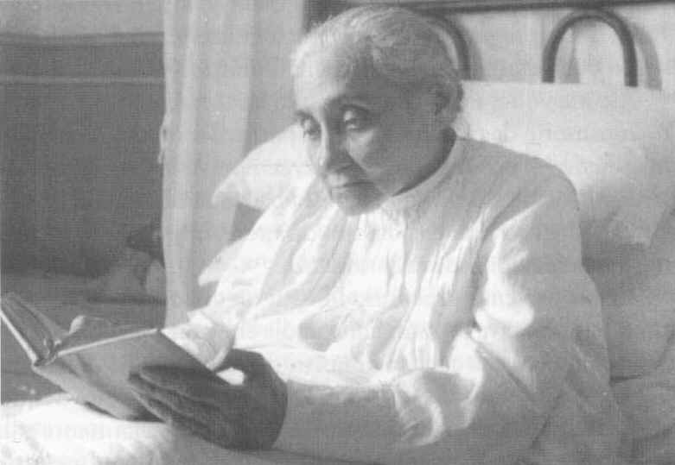

Luisa Piccarreta reading the Sacred Scriptures

**The bell of discord**

Aunt Rosaria, the co-owner of family property, had renounced in our favor practically half her income, which at that time could be considered a substantial sum, because we were a large family, six children, all at school. She would come for a meal at home almost every day and felt in command of the situation. The work my aunt did at home was invaluable, especially as regards domestic chores: she assisted with the cooking, set the table and helped to clear before she left.

Her contribution was much appreciated, for my mother was a teacher and we were all at school and found it difficult to attend to the housework. The few times that Aunt Rosaria did not come, there was pandemonium and everything was rushed. I remember that when we got back from school we would always find Aunt Rosaria ready to encourage us to wash our hands and make the sign of the cross before we started eating.

Sometimes however, she gave signs of a strangeness that prompted us, especially my mother, to protest. Her behavior seemed to us insolent, challenging, as though she wanted to assert that it was she who was mistress of the house.

This also depended on her strong and independent character, which made her reluctant to confide in others.

Her presence threw everyone into a certain confusion, no one daring to say a word out of place, and she seldom complied with any of our wishes: she never gave us little gifts or pocket-money. She was only available when we showed a desire to go to confession or to church, especially vespers, which she never missed. She regularly attended the parish of Santa Maria Greca and she was to be found in the chapel of the Blessed Sacrament kneeling in her usual place. When we looked for her for some family matter, if she was not at Luisa’s house we would find in the church her kneeling in her customary place. One day I said to her: "Don’t your knees hurt?" She smiled at me and, not answering the question, added: "*This is the place where Luisa knelt when she could come to church. And this is where Luisa spoke to Jesus*".

Her strange conduct was annoying, and as a result some rather harsh remarks were made in our household. The causes of the family quarrels, especially between my aunt and my mother, were the following.

Very often, while we were eating, our aunt would leave the table in a hurry, put on her overcoat and go.

On other occasions, when important family affairs were being discussed, she would cut the conversation and disappear. This behavior of hers left everyone speechless, because it had no logical explanation. Aunt Rosaria was therefore considered a false and hypocritical woman and my mother attributed this attitude to her pride. Only my father, who was very fond of his sister, kept the balance and always made excuses for her, provoking the anger of my mother who felt offended by the lack of consideration he showed for her observations on our aunt.

As children, we sided with our mother, considering Aunt Rosaria the black sheep of the family and the object of our sarcasm. Our mother’s intervention was required to moderate our indiscreet insistence. In spite of all this, my mother held Aunt Rosaria in high esteem and warned us: "*Remember, she is nonetheless a consecrated soul!*".

Perhaps what most upset us was that the following day Aunt Rosaria would present herself at home as though nothing had happened, and never responded to my mother’s requests for an explanation of her attitude.

As a priest, when my aunt was already very old and the object of the family’s veneration, I asked her the reason for her behavior. She said to me: "*Do you really want to know? Are you so very interested?*". "Yes", I answered.

So she began to speak: "*I suffered deeply from misunderstandings, but those were the tremendous tests to which the Lord subjected me, to make me a worthy custodian of Luisa. She used to spend many hours of the day in prayer. I guessed when she wanted to be left alone, without her saying anything to me. I would get up from my work, take her lace-making pillow from her, put it on the table and make everyone leave the room. I would draw the curtains round the bed, and close her door, and work would continue in silence in the next room. Many hours would pass and when I heard the bell, I would enter Luisa’s room alone; I would draw back the curtains round the bed and I would put the lace cushion in her hands, so that everyone, returning to her room would find her as they had left her, intent on her work. In the morning, too, while I was still in bed, I was the only one who heard her bell, sometimes at about three or four o’clock. Her sister, Angelina, grumbled because she was woken by hearing me getting up. I would go to Luisa’s room and find her as though dead, showing no signs of life, motionless. I would arrange her hair and put the pillows, which I often found on the floor, behind her back. It should be noted that pillows (three) were placed behind Luisa, but she never leaned back on them, they only served to fill the space between her body and the bed-head. Having tidied Luisa, I would prepare the altar for Holy Mass. When the priest arrived for the celebration, I would let him in to the room alone. He would make the sign of the cross over her body and call her back to life. Once Luisa had returned to normality, all the others would enter to take part in Holy Mass, including the ever present altar-boy. Luisa participated in Holy Mass as though she were in ecstasy, with very great devotion and responding in perfect Latin. After communion, everyone left, while Luisa immersed herself in a lengthy and deep thanksgiving which lasted several hours. Towards nine o’clock in the morning she would ring her bell, at which we would enter her room and begin the lace-making. I worked beside Luisa and we used the same bobbins, the same thread and the same pins, and I would correct Luisa’s work because her stitches were somewhat loose since she had not the strength to pull the threads tight, because of the pain in her hands due to the stigmata she had received*".

At this point I interrupted her and said: "But I never saw the stigmata on her hands!".

She answered me: "*Of course not, because they were internal and only I and a few other people saw them. Among these were her confessors and the Cimadomo sisters, and I think her niece, Giuseppina, too. In fact, if one took Luisa’s hand and held it up to the light, the internal hole was visible. When I entered her room during the night, I would frequently find her covered in blood: so much blood was seeping from her feet, her hands and her side, that her nightdress and the bed were soaked in it. Sometimes, the blood was even dripping onto the floor. Not only her body, but her head and face were also covered in blood: she seemed crucified. The first time I was deeply shocked, believing her to be dead through loss of blood, and I ran to fetch cloths to clean her, but when I returned I found her absolutely clean, except for the sheet. It had all disappeared. This phenomenon would occur two or three times a year*".

"But you", I said to her, "you never told anyone about this phenomenon?".

"*No*", she replied, "*only Fr. Benedetto Calvi knew of it. He absolutely forbade me to speak of it, and said that he would deny me absolution if I were ever foolish enough to tell anyone about it. You are the only one to know, and I hope that Luisa will not take it badly*".

After a pause she continued. "*I beg you not to tell of this phenomenon*"*.*

She gave me the impression that she regretted having told me of it. Indeed, it was the first time that she had ever mentioned it.

This is one of the many phenomenaconcerning Luisa’s life which had continued to be unknown.

My aunt, after a long pause, went on: "*Luisa usually worked only for churches, she would make pieces of lace for altar cloths, vestments and cassocks for priests. Sometimes, when they pestered her, she would make lace bedspreads for young couples. Luisa had a special soft spot for the sanctification of families, and many young husbands and wives would go to her for advice. How much good she did, and how many families did she save from ruin! I would leave the house when Luisa withdrew into prayer and when I returned, shortly afterwards, she would ring her bell, so I was not at all worried. Whenever I had to go away for a few days, her niece, Giuseppina, replaced me. But sometimes when I was somewhere else, at home, in church or at some friend’s house, I would hear her bell; I would interrupt anything, even lunch, and hurry to Luisa’s house. Because of my way of doing things I was considered odd, not only by the family but also by strangers. I could give no explanations because I alone could hear the sound of her bell and if I had told others, they would have taken me for a mental case and a visionary, so I was silent and when pressed to give a reason for this attitude, I always tried to change the subject, pretending not to hear. All this caused me immense suffering. Often after a great rush to get to her, I would find Luisa still praying*".

I asked her: "And who was ringing the bell?".

"*I don’t know*", she replied.

"And what did Luisa say?".

"*Nothing*".

"And what did you do?".

"*I knelt down beside her bed and prayed*".

"But didn’t you notice anything while Luisa was praying? Is what has been said of Luisa true, that she was often suspended in the air?".

"*I cannot speak of these things, Luisa always forbade me to speak of them. Her confessor was the only one to know everything, and he was the repository of her extraordinary phenomena. Luisa, for her part, always pretended that nothing had happened, nor did she allow a single word to be said of it. It all had to be submitted to the authority of the priest and he alone could decide whether the phenomena were to be divulged. Luisa did nothing and wrote nothing without the authorization of her confessor, she was so submissive to the Church’s authority that nothing was to be known or written and divulged without his permission. It is on these lines that it will be possible to know all about Luisa; it is all recorded in her writings*"

I added: "But her writings can’t reveal everything about Luisa’s life, because it was far more complex".

"*That’s true*" she answered. "*I could tell of many things that no one knows*".

"So why do you insistently refuse to speak?" "*If Luisa had wished them to be known she would have written them down, or the Church would have ordered her to write them; it is clear that certain phenomena which occurred, which I and others witnessed, do not serve for the sanctification of souls. The Lord permitted to be known all that is of use to the Church and to souls, the rest serves no purpose. In speaking of these things I feel as if I were profaning the intimacy that was built up between God and Luisa, human beings would not understand. The message bequeathed by Luisa exceeds her very person. Luisa wanted the Lord alone to have all the honor and glory, and she was to disappear into nothingness; this is why she loved solitude and silence, and showed great distress when she noticed that she was the object of people’ veneration, for she considered herself only a poor sick person, in need of everything. I and others knew very well that Luisa had no need of anything, and that we had to be the custodians of her mystery. How often in the morning did I find Luisa all tidy and the altar already prepared for Holy Mass with the candles lit*".

"And how did this happen, if Luisa never set foot out of bed for about sixty years? Are you sure of what you say?".

"*Absolutely certain! Because I was the only one who entered her room*"

"Did you never wonder what the explanation was?".

"*I thought that Angels served her, especially her guardian Angel, to whom she was deeply devoted. Her room was often found full of fragrance*".

"And did others smell this fragrance?".

"*Yes, those who took part in Holy Mass. I remember that once Fr. Cataldo De Benedictis, who had come to celebrate Holy Mass in the absence of her confessor, said to me: ‘Don’t scent the room, or I will come out with a headache’. I assured him that no one had put scent in the room, but he did not believe me*".

"Is it true that Luisa vomited everything she ate?".

"*Yes. However, this phenomenon was common knowledge, because Luisa was to live on God’s Will alone. But many did not believe it, and thought that she must be eating something*".

"I saw this too, several times, when I came to visit you in Luisa’s house".

"*So then what else do you want to know? A lot of food was wasted, and at the time, as you know, poverty was widespread. I also pointed this out to Luisa, even if her food was so scant that it would have hardly sufficed to keep a new born baby alive. Her answer was:* ‘*Let us obey*’. *In fact her confessors were adamant, harsh and inflexible about this phenomenon. It seems to me that there was a precise order from the Bishop. Once the confessor told me very firmly : she must eat every day and every one must know that she eats, or they will set the police at her door as they did with Teresa Newmah, with all the publicity of the newspapers*"*.*

"But did she drink water or other liquids?".

"*I never gave her water to drink; she drank nothing but the juice of bitter almonds which the Cimadomo sisters would bring her. Sometimes your sister Isa also prepared this juice, which she extracted from Aunt Nunzia’s almonds*".3

"But don’t bitter almonds contain a poisonous substance? And in the long term don’t they harm the organism?".

"*That I can’t say, but I can assert with a clear conscience that it was the only liquid she drank without vomiting*"*.*

"Was it at least sweetened?".

"*No*", she replied, "*now that’s enough, I have said almost all that I could say, which moreover, was common knowledge*"*.*

"But I would like to know more!".

"*No! That is merely curiosity; if Luisa so wishes, I will be able to tell you a great many other things, and then it will be I who call you*".

So ended my conversation with Aunt Rosaria.4 It was October 15, 1970.

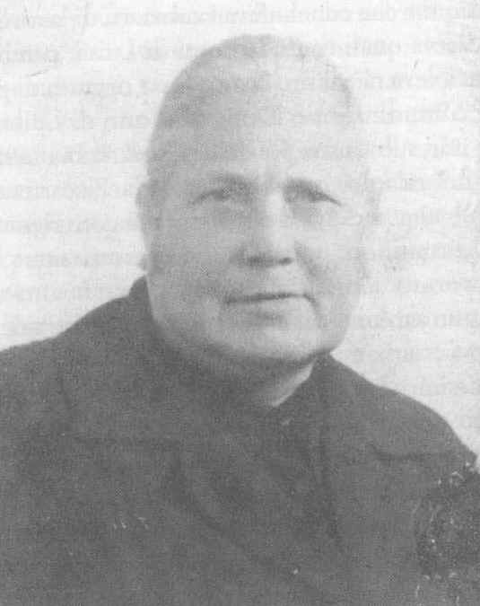

Rosaria Bucci, who lived with Luisa Piccarreta for forty years.

**A perfect lace-maker**

Despite the mutilation of her fingers on one hand, Aunt Rosaria became a perfect lace-maker, to the wonder of all. She perfected Luisa’s work and taught all the girls who took the lace-making and embroidery course. In addition, she made herself indispensable and in fact, after the death of Luisa’s parents, became her housekeeper. It was she who received the commissions and finalized the work contracts. However, she told no one which pieces of lace had been made by Luisa, because the Servant of God did not want her own work to be the object of special attention or admiration. After Luisa’s death, the embroidery work did not cease, for Aunt Rosaria kept alive the tradition of lace-making and embroidery which Luisa had caused to flourish. That Aunt Rosaria was a perfect lace-maker was considered by all as a never-ending miracle, since her physical handicap was such as to prevent from her doing this kind of delicate craft. For work that could have earned millions – since it required years to complete – extremely modest sums were requested. This is why we nephews and nieces complained to our aunt, at which she used to reply: "*Money does not matter much. What is important is to be able to live*". Aunt Rosaria told us that Luisa had categorically forbidden her to accept money for any reason, especially donations. If, by chance, sums of money arrived in letters, these letters were immediately returned to the sender. Luisa would say that what she possessed was too much for her and that she had no need of anything. The small sums which they earned from their work were sufficient to support Aunt Rosaria and Luisa's sister, Angelina. The way the Servant of God answered Blessed Annibale when he tried to give her the royalties for the works she had published is typical: "*I have no right*", she said, refusing the money the blessed had offered her, "*because what was written is not mine*"*.*

The mysterious sores

In about 1940, my Aunt Rosaria, a robust woman shining with health, developed sores which in time grew bigger and more purulent, *although she felt no pain*. Two big sores in particular, like two large swollen boils, were visible under her chin. These boils secreted pus almost all the time, and a few drops even fell into her plate while we were having lunch. I felt a sense of disgust during these unpleasant situations and tried to keep away from the table, but my mother, in order not to aggravate the embarrassment this caused us, would restrain me with her hand and, from time to time, pinch me. Aunt Rosaria, as a co-owner of the family possessions, often came home for meals. Her sores, which spread all over her body, especially on her breast and shoulders, were lovingly disinfected by my mother, who urged her to go to Bari to see a specialist. But one day my aunt sat down to eat completely cured. In fact, there were small scars where the sores had been. No one made any comment; only when my aunt was leaving did my father retort, remembering previous and new episodes: "*Ched femn c fatt’ vdai caus nov*" (that woman has always made us see new things), referring to Luisa. My father also had a great devotion for Luisa the Saint and on his deathbed he wanted to clasp her nightdress to his breast. My mother was wearing this same nightdress at the time of her own departure for heaven.

But what had happened to my aunt?

This is her account of what occurred, given during one of the visits I regularly paid her when I was curate at the Friary of Barletta.

My aunt, urged by my mother, consulted a dermatologist in Bari. The diagnosis was terrible: "*Dear lady*", the doctor said to her. "*these are cancerous sores which will spread increasingly over your whole body. You have a form of leprosy, a very rare disease*". Just imagine my aunt’s state of mind on hearing these words. After wandering about in Bari for several hours, in the evening she returned to Luisa’s house. Aunt Rosaria gave vent to her feelings with the Servant of God and said to her with irritation: "*I’m with you all the time, and yet do you allow certain things? I have no children to take care of me.*". Luisa let her speak and then said to her, "*Rosaria, Rosaria... you have gone round all these doctors and you have neglected the one true doctor*". On hearing these words, my aunt immediately took all the medicines, gauze and cotton wool, and flung them away, from the balcony (this happened in the house in the Via Maddalena, where they then lived). Then she said: "*I now entrust myself to Our Lord and to your prayers*". Before she went to bed, Luisa called her, made her kneel beside her bed and together they spent a long time praying. My aunt then went to bed. She slept in a double bed beside Angelina. That night, Aunt Rosaria felt her body flooded with a sense of well-being. When she rose the next morning she found that all her sores had dried up; they were covered only by thin scabs which came off during the day: she was perfectly cured. Rumors of the miracle spread, but no one dared to speak of it openly although everyone knew that Luisa had had a hand in it. The reason for this was that Luisa did not want these phenomena to be attributed to her. "*I cannot work miracles, it is Our Lord who does them*", she asserted. This is why no extraordinary episode that occurred through her intervention was made public; all the same, news of such matters spread in silence.

**Blessed Padre Pio, Luisa Piccarreta and Rosaria Bucci**

Luisa Piccarreta and Blessed Padre Pio of Pietrelcina knew one another for some time without ever having met, for Luisa was always confined to the bed where she sat, while Padre Pio was enclosed in the friary of the Capuchin Fathers of San Giovanni Rotondo.5

One question naturally arises, how did they come to know one another?

This is difficult to discover, yet one thing is certain, that the two did know and esteem one another.

My aunt recounts how Luisa would speak with respect and veneration of the blessed father, describing him as a "*true man of God*", who still had great suffering to face for the good of souls.

In about 1930, a well-known figure arrived at Luisa’s house, sent personally by Padre Pio. He was Federico Abresch, a convert of Padre Pio. Federico spoke at length with Luisa. What they said we are not given to know; but one thing is certain. Federico Abresch became an apostle of the Divine Will and regularly visited Luisa, with whom he always had long conversations.

When his little son received his first communion from Padre Pio’s hands, he was also immediately taken to see Luisa who, according to the story, foretold that he would become a priest.

The small boy of that time is now a priest and works at the Congregation for Bishops in Rome; he is known by the name of Mgr. Pio Abresch.

When Luisa was condemned by the Holy Office and her works put on the Index, Padre Pio sent her this message though Federico Abresch: "*Dear Luisa, saints serve for the good of souls, but their suffering knows no bounds*". At that time Padre Pio was also in very great difficulties.

Blessed Padre Pio sent many people to Luisa Piccarreta and would say to the people of Corato who went to San Giovanni Rotondo: *"What have you come here for? You have Luisa, go to her*".

Padre Pio recommended to certain of his faithful (including Federico Abresch) that they open a spirituality center at San Giovanni Rotondo, inspired by the Servant of God Luisa Piccarreta.

Miss Adriana Pallotti (a spiritual daughter of Padre Pio) is currently an heir to Padre Pio’s wishes. She has opened a House of the Divine Will at San Giovanni Rotondo, keeping alive the torch lit by Padre Pio with Federico Abresch. Miss Adriana Pallotti says that it was Blessed Padre Pio who encouraged her to spread Luisa Piccarreta’s spirituality in San Giovanni Rotondo and to help disseminate the Divine Will throughout the world, as Padre Pio desired.

Aunt Rosaria went regularly to San Giovanni Rotondo, especially after Luisa’s death. Padre Pio knew her very well, and when Luisa was still alive he would ask Aunt Rosaria when he saw her: "*Rosa’, how is Luisa?*".

Aunt Rosaria would answer him: "*She is well!*".

After Luisa’s death, Aunt Rosaria increased her visits to San Giovanni Rotondo, in order to receive enlightenment and advice from Padre Pio.

Aunt Rosaria was the one lamp that stayed alight to resolve Luisa Piccarreta’s case regarding the sentence of the Holy Office, visiting various ecclesiastical figures and, in addition, confronting the Congregation of the Holy Office. Once she managed – it is not known how – to enter the office of the Cardinal Prefect, Ottaviani, who heard her kindly and promised to take up the case.

Indeed, a few days later, Aunt Rosaria was summoned by Archbishop Addazi of Trani, who said to her: "*Miss Rosaria, I do not know whether to reprimand you or to admire you for your courage. You have faced the guard dog of the Church, the great defender of the faith, without being bitten*".

The conclusion was that permission was obtained to move Luisa’s body from the cemetery to the Church of Santa Maria Greca.

Luisa said to my aunt: "*You will be my witness*" and one day Padre Pio told her point-blank in his Benevento dialect: "*Rosa’, va nanz, va nanz ca Luisa iè gran e u munn sarà chin di Luisa*" (Rosaria, go ahead, go ahead for Luisa is great and the world will be full of Luisa). My aunt often recounted this episode, but things were not going well: everything indicated that Luisa would soon be forgotten.

After the venerated Padre Pio’s death, my aunt said one day: "*Padre Pio prophesied that Luisa would be known throughout the world*". And she repeated the phrase Padre Pio had said in his dialect.

I answered that there would be no easy solution to the case of Luisa Piccarreta Indeed nothing further was said of it in Corato either, and Padre Pio’s words could have been considered merely a comforting remark. But Aunt Rosaria retorted: "*No! During my confession Padre Pio told me that Luisa is not a human factor, she is a work of God and he himself will make her emerge. The world will be astounded at her greatness; not many years will pass before this happens. The new millennium will see Luisa’s light*".

I was silent at this assertion and my aunt asked me: "*But do you believe in Luisa?*"*.*

I answered her that I did.

Then she said to me: "*Come to my house in a few days’ time, because I have something very important to tell you*".

It was during the 70s and Padre Pio had been dead for a several years.

**Aunt Rosaria’s secret**

In 1975, on 2 February to be exact – I remember it was a very chilly day – my aunt summoned me to her house. She was very old and was beginning to have problems with her sight, due to diabetes. My nephew and niece, Vincenzo and Sara, went to her house to keep her company.

That day, I found her sitting at the window as she recited the Rosary.

I sat down next to her, and having greeted her, asked her what it was she wanted to tell me that was so important.

She looked at me and said: "*What I am going to tell you now is of the utmost importance. Try to use it well and I urge you to meditate on the miracles of the Lord who gave us Luisa, a precious creature in God’s eyes and an instrument of his mercy. You would find it hard to discover such a precious, great soul. Luisa goes beyond herself, and you can only contemplate her fully in God’s mystery. Mary was the One who brought redemption into the world with her* Fiat, *which is why the Lord enriched her in such a wonderful way that she became a creature who was raised to the dignity of Mother of God. Mary is the Mother of God, and no other creature will ever equal her in greatness and power; after God it is she alone who expresses the Lord’s marvels to the world. After Our Lady comes Luisa, who brings the world the third* Fiat, *the* Fiat *of Sanctification*".

She said this quietly, marking her words well, convinced of what she was asserting. I was overwhelmed by these assertions.

"*That is why Luisa was always nailed to her bed and every day offered to the Divine Majesty as a victim of expiation to God’s Most Holy Will*", she continued. *"God was pleased with this creature and so jealously guarded her that he removed her from human beings, entrusting her only to his Church, so that she could preserve her and humanly forge her with infinite penances and misunderstandings. My Luisa knew no human consolations but only divine ones; her body was continually suspended between heaven and earth, and her earthly life was a continuous contradiction in comparison with normal human lives. Even in her body, she had to belong entirely to God*".

She then confided to me: "*One day the Lord said to Luisa: ‘all those who have seen and known you will be saved*’".6

"*Dear Peppino, this is an extraordinary gift of God and it has remained shrouded in silence because Luisa did not want knowledge of it broadcast, or she would have become the object of curiosity or veneration which, she said, she did not deserve. Except that one day her confessor told me that I could speak of it and spread it with discretion. Now I have told you, in the hope that you may be able to make good use of it*".

That day I was left enchanted by the language used by Aunt Rosaria, who expressed theological concepts perfectly, and even in a poetic vein.

By accident, the notes I had made were lost and I have limited myself to writing what I remember.

Her death, almost unexpected, gave me no time to ask her further questions, which would have provided a clear explanation of what she had told me.

**Aunt Rosaria died in 1978.**

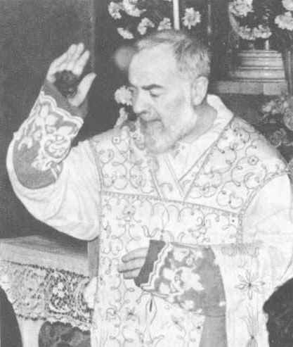

**The bleeding hand of Padre Pio of Pietrelcina was raised thousands of times to bless the faithful at the end of Holy Mass**

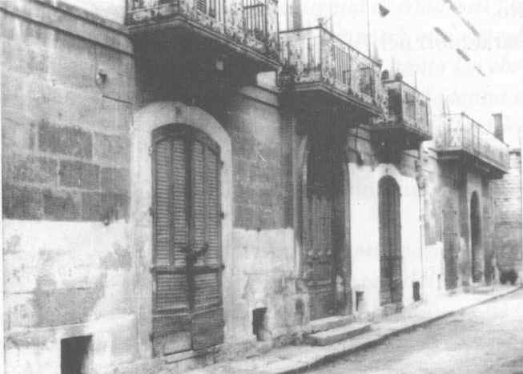

Corato, Via Maddalena: the house where the Servant of God Luisa Piccarreta lived in the last years of her life