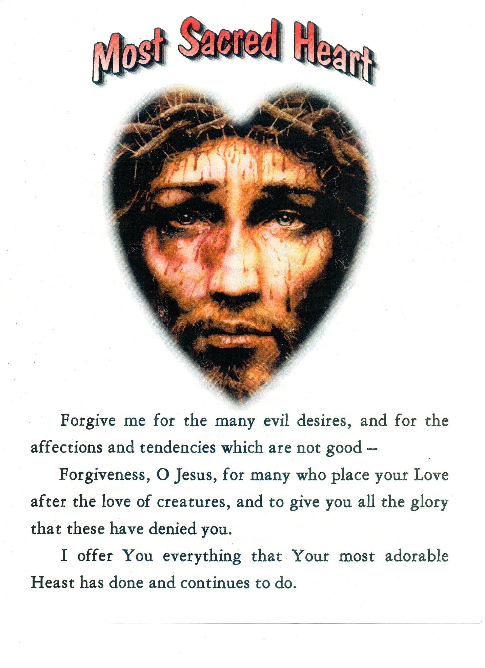

Twenty-Second Hour
2-3 p.m.

Our Lord’s
Head
Give me forgiveness for the many thoughts of pride, of ambition and of self-esteem.

Beautiful Eyes
I ask Your forgiveness for all the times I have offended You with evil and immodest gazes.

Sacred Ears
Forgive me for all the times I have listened to, or made others listen to discourses which move us away from You, and for all the evil discourses made by creatures.

Most Holy Face
Forgive me for the many scorns, offenses and insults You receive from us, most miserable creatures, with our sins.

Most Sacred Mouth
Forgive me for all the times I have offended You with evil discourses: for all the times I have contributed to embittering You and increasing your thirst.

Most Holy Neck
Forgive me for the many bonds and many attachments of the creatures, which have increased the ropes and chains around Your Most Holy Neck.

Most Holy Shoulders
Forgive me for the many illicit satisfactions; forgiveness for the many sins committed with the five senses of our body.

Most Holy Breast
Forgive me for all the coldness, indifference, lukewarmness and horrendous ingratitude.

Most Sacred Hands
Forgive me for all the evil and indifferent works: for many acts rendered malicious by love of self and self-esteem.

Most Sacred Feet
Forgive me for the many steps, the many paths covered without righteous intentions; and for the times I move away from You and go in search of the pleasures of the earth.

